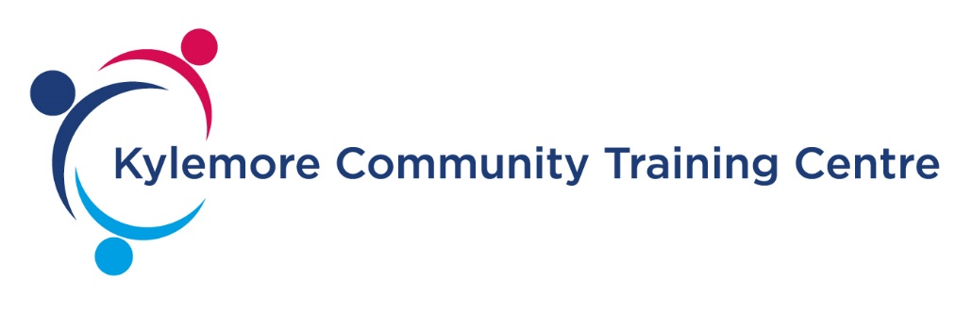

1ST FLOOR BALLYFERMOT RESOURCE CENTRE,
BALLYFERMOT ROAD, DUBLIN 10.
D10 K319
(01) 6231356 INFO@KYLEMORECTC.IE

Job Title: Community Training Centre (CTC) General Manager.

Responsible to: Board OF Management

Responsibility for others: CTC Staff & Programme participants.

AIMS OF THE POST:

To effectively manage the day to day running of the community based training centre. The primary objective being to involve the optimum number of participants and to manage the development of a comprehensive programme which will facilitate the positive development of the CTC.

To create an environment within which learners achieve an agreed level of accreditation and progression outcomes.

To harness all available resources to achieve the organisation’s aims and targets.

DUTIES AND RESPONSIBILITIES:

The CTC Manager is responsible for the leadership and co-ordination of the CTC’s day-to-day operational matters. The post holder will help to devise, implement and review CTC priorities guided by KCTC strategies and plans which s/he is responsible for producing and achieving with staff. The CTC Manager creates an effective working environment in which goals can be met.

DUTIES:

- To manage services ensuring maximum efficiency and value for money.
- To co-ordinate the development, delivery and review of services and activities.
- To ensure that appropriate certification is available for all progammes and accreditation standards are maintained.
- Assist in developing links with employers and other agencies to promote progression to employment and/or further training and education opportunities.
- Ensure the provision of appropriate Learner recruitment, assessment and monitoring practices including tracking those who have left the centre.

- Coordinate the rolling strategic and annual planning and review process and report to the Board on implementation.
- Prepare plans and budgets for Board approval and ensure other reports and returns are submitted to the relevant party on time.
- Liaise with the CDETB and others to ensure the smooth operation of the centre.
- Attend meetings and provide regular written reports to the Board and the ETB as appropriate.
- Work with the Board to ensure policies, procedures and records are in place and in accordance with legislative and operational requirements.
- Co-ordinate the development and integration of services for new and emerging client groups and respond to new national policy initiatives and services
- Co-ordinate the implementation of a Quality Assurance Framework and work with the board, staff and others to identify key performance indicators for service delivery.
- Lead, motivate and develop staff through regular communications, meetings, staff training and development initiatives. Deal with personnel issues.
- Network, liaise and develop working relationships with the funding agency and local groups / schools / employers, and other relevant bodies.
- To have responsibility for the KCTC premises including provision of suitable work space; health and safety aspects; repair, maintenance and security of buildings.
- Carry out other duties that may be assigned from time to time
- This job description is not a complete or exhaustive list of tasks and duties, but a guide to the main areas of responsibility in the job. The post holder may be asked to take on other duties from time to time as reasonably requested by the CEO.

PERSON SPECIFICATION

The post holder needs to demonstrate the following:

Essential Requirements:
- A relevant degree level qualification or equivalent and significant management experience of at least 5 years.
- A learner centred approach to the work with the ability to integrate services for new and emerging learner groups.
- The ability to work effectively with management and ETB requirements.
- Demonstrable leadership qualities, including flexibility, ability to motivate others and experience as a manager of tasks and people.
- Have excellent communication, leadership and I.T. skills.
- A working knowledge of QQI Awards, and Quality Assurance Frameworks.
- Experience and competence in financial administration and budgets.
- Strategic & business planning experience with knowledge of application.

Desirable Qualities
- Effective negotiating skills, preferably demonstrated with senior staff of other agencies to secure resources, to develop inter-agency work and to innovate.
- Administration experience, including knowledge of IT and managing effective administrative systems.
- Experience of teamwork or group work.
- Personal qualities of approachability, energy and enthusiasm, ability to work well under pressure, ability to manage uncertainty.
- A working knowledge of further education and training strategies and the role of agencies who work with early school leavers are essentials.
- Experience of and commitment to the values of life long education service provision, a vision and sense of purpose about the education and service requirements of early school leavers.
- Ability to think conceptually, to make connections between ideas and to see possibilities put into practice.
- Proven ability to overcome obstacles, determination to achieve goals, confidence about turning problems into solutions.
- Openness to learning, development and change.
- Planning and organising skills.

